Our software will be divided into three sections:

* preschool: 5-7 year
  + - Math (Numbers, logic operations)
* Example: ICE TOWER
  + - Letters/Words
* Example: ABC kids
* Fruits/Vegetables/ Animals
* elementary school: 8-11 year
  + - Health Education(Optional)
    - Time
    - Date
    - Advanced Math
* Middle school 12-15 year
  + - Problem solving
    - Logic gates
    - Biology(Optional)
    - Advanced Problem solving

**Preschool**

|  |  |  |  |
| --- | --- | --- | --- |
| Math | **Description** | **Game Structure** | |
| Math learning game designed to teach young children numbers and simple mathematical operations. It features several mini-levels that toddlers and pre-K kids will love to play, and the more they do the better their math skills will become! | **levels** | **10** |
| **points** | **4 per level** |
| **outcomes** | **achievements** | 2(babysteps,15)(cliverbaby,30) |
| Our game give students opportunities to explore fundamental number concepts, such as the counting sequence, Addition, and Subtraction.  Engaging in mathematical games can also encourage students to explore number combinations, place values, patterns, and other important mathematical concepts. | **User flow** | When the user open the game he/she will found a bunsh of levels which curriculum has been divided on it in a correct way to get the best learning.  when the user start the level he/she will notice that the screen is divided to three sections, The first one lay on the top of the screen and containes the navigations and the progress & Time information, The second section lay on the middle of the screen and containes the game information like the questions that will be displayed to the user, Third section lay on the bottom of the screen and containes the answer of the question in form of choices and the user have to choose one of the choices.  There will be Animate scenes and characters which will help the user to pass the level successfully.  The last 5 levels of the game will contain a different game structure, it will contains a game where the player's goal is to jump from one "floor" to the next and go as high as possible without falling and this will happen when the user jump on the right floor after he/she solve the equation that displayed to them. The higher the player's character climbs, the faster the tower's floors move downward and the harder the game becomes. |

|  |  |  |  |
| --- | --- | --- | --- |
| Letters/Words | **Description** | **Game Structure** | |
| The game concept simply means that a student understands that each little group of letters in a sentence is a word, that a space separates words, and that each word has a meaning and is a spoken word. | **levels** | **10** |
| **points** | **4 per level** |
| **outcomes** | **achievements** | 2(babysteps,15)(cliverbaby,30) |
| In addition to their entertainment value, these games may provide some benefits :  Build your vocabulary.  Introduce users to new words.  Improve focus.  Stimulate the brain. | **User flow** | When the user open the game he/she will found a bunsh of levels which curriculum has been divided on it in a correct way to get the best learning.  when the user start the level he/she will notice that the screen is divided to three sections, The first one lay on the top of the screen and containes the navigations and the progress & Time information, The second section lay on the middle of the screen and containes the game information like the questions that will be displayed to the user, Third section lay on the bottom of the screen and containes the answer of the question in form of choices and the user have to choose one of the choices.  There will be Animate scenes and characters which will help the user to pass the level successfully.  The first 5 levels of the game will represent the letter learning and then the last 5 levels will represent the learning of words and how to make a sentence. |

|  |  |  |  |
| --- | --- | --- | --- |
| Fruits/Vegetables/ Animals | **Description** | **Game Structure** | |
| In the game, your main task is to determine the type of fruits, vegetables, and animals as soon as possible. With each level, the game will become more and more challenging. | **levels** | **15** |
| **points** | **4 per level** |
| **outcomes** | **achievements** | 2(babysteps,15)(cliverbaby,30) |
| The main goal of this game is to add new information to the user, such as types of fruits and vegetables, and also make him able to differentiate between different animal shapes and know their sounds, and this is very good for the development and improvement of children's minds at the beginning of their lives. | **User flow** | **When the user open the game he/she will found a bunsh of levels which curriculum has been divided on it in a correct way to get the best learning.**  **when the user start the level he/she will notice that the screen is divided to three sections, The first one lay on the top of the screen and containes the navigations and the progress & Time information, The second section lay on the middle of the screen and containes the game information like the questions that will be displayed to the user, Third section lay on the bottom of the screen and containes the answer of the question in form of choices and the user have to choose one of the choices.**  **The first 5 levels of the game will represent the fruits learning and then the second 5 levels will represent the learning of vegetables and then the last 5 levels will represent the learning of the different animals.**  **There will be Animate scenes and characters which will help the user to pass the level successfully.** |

**ElemntrySchool**

|  |  |  |  |
| --- | --- | --- | --- |
| Advanced Math | **Description** | **Game Structure** | |
| Math learning game designed to teach young children numbers and simple mathematical operations. It features several mini-levels that toddlers and pre-K kids will love to play, and the more they do the better their math skills will become! | **levels** | **10** |
| **points** | **4 per level** |
| **outcomes** | **achievements** | 2(babysteps,15)(cliverbaby,30) |
| Our game give students opportunities to explore more advanced math concepts, such division, and multiplication.  Engaging in mathematical games can also encourage students to explore number combinations, place values, patterns, and other important mathematical concepts. | **User flow** | When the user open the game he/she will found a bunsh of levels which curriculum has been divided on it in a correct way to get the best learning.  when the user start the level he/she will notice that the screen is divided to three sections, The first one lay on the top of the screen and containes the navigations and the progress & Time information, The second section lay on the middle of the screen and containes the game information like the questions that will be displayed to the user, Third section lay on the bottom of the screen and containes the answer of the question in form of choices and the user have to choose one of the choices.  There will be Animate scenes and characters which will help the user to pass the level successfully.  The last 5 levels of the game will contain a different game structure, it will contains a game where the player's goal is to jump from one "floor" to the next and go as high as possible without falling and this will happen when the user jump on the right floor after he/she solve the equation that displayed to them. The higher the player's character climbs, the faster the tower's floors move downward and the harder the game becomes. |

|  |  |  |  |
| --- | --- | --- | --- |
| Time | **Description** | **Game Structure** | |
| In this game child will learn to read the time he will start with easy numbers then he will be able to read more hard stuff and learning the right pronounce . | **levels** | **5** |
| **points** | **4 per level** |
| **outcomes** | **achievements** | 1(Junior) |
| the child will be able to fully read the time from any clock and he will know the difference between AM and PM | **User flow** | **When the user opens the game he/she will find a bunch of levels in which the curriculum has been divided on it in the correct way to get the best learning.**  **when the user starts the level he/she will notice that on the right side of the screen we will find a large clock with two colors clockwise in the left side of the screen will be total points or score and at the bottom there are some rectangle shapes which we will put the numbered time in it.** |

|  |  |  |  |
| --- | --- | --- | --- |
| Date | **Description** | **Game Structure** | |
| learning the names of the months is a challenge for the kid to remember them all so by making the game itself easy and remarkable the child will not need and memory strength to remember them. | **levels** | **5** |
| **points** | **4 per level** |
| **outcomes** | **achievements** | 1(Junior) |
| the child will be able to remember the twelve month with the number so he does not memorial process | **User flow** | **When the user opens the game he/she will find a bunch of levels in which the curriculum has been divided on it in the correct way to get the best learning.**  **when the user starts the level he/she will notice that on the right side of the screen a large container rectangular shape contain the months names and in the left side of the screen another large container rectangular shape but contain number from one to twelve and the child will match the number with the month name by a dragging the arrow to the month name.** |

**MidSchool**

|  |  |  |  |
| --- | --- | --- | --- |
| Problem solving | **Description** | **Game Structure** | |
| through a series of logical problems presented as a racetrack, the game is to lead the race car toward the finish line using direction bricks.  Our game introduces pre-coding by way of a set of logic puzzles laid out as a racetrack. | **levels** | **10** |
| **points** | **4 per level** |
| **outcomes** | **achievements** | 1(Junior) |
| our game explains pre-coding the game teaches kids the fundamentals of coding while they play! | **User flow** | **in the middle of the screen, we found the car track**  **with different shapes and barriers, above it we find the available directions section you can select from them to play and pass this level.**  **once you select the direction, the direction goes to the execution section on the left of the screen, and the execution section store the directions you have selected.**  **after you finished your directions hit the play button, the play button makes the car move based on the directions in the execution section.** |

|  |  |  |  |
| --- | --- | --- | --- |
| Advanced Problem solving | **Description** | **Game Structure** | |
| lead a small blocky penguin through each stage while collecting as many coins as you can in a specific time. | **levels** | **5** |
| **points** | **4 per level** |
| **outcomes** | **achievements** | 1(Junior) |
| our game explains pre-coding the game teaches kids the fundamentals of coding while they play! | **User flow** | **The playground, which has various shapes, barriers, and coins, is in the center of the screen. To play and complete this level, choose from the function section on the right.**  **Once you've chosen the functions you want, they will appear in the execution section on the left side of the screen, where they will be stored.**  **When you press the play button after finishing your functions, the automobile moves in accordance with the functions you entered in the execution area.** |

|  |  |  |  |
| --- | --- | --- | --- |
| Logic gates | **Description** | **Game Structure** | |
| The working of this game is pretty straightforward. There are 6 gates with the help of which we have to make a specific combination to turn ON a LED | **levels** | **10** |
| **points** | **4 per level** |
| **outcomes** | **achievements** | 1(Junior) |
| Learn logic gates(AND, OR, NOT, NAND, NOR) and how to deal with them, basic knowledge of programming while they play! | **User flow** | When the user open the game he/she will found a bunsh of levels which curriculum has been divided on it in a correct way to get the best learning.  when the user start the level he/she will notice that the screen is divided to three sections, The first one lay on the top of the screen and containes the navigations and the progress & Time information, The second section lay on the middle of the screen and containes the game information like the questions that will be displayed to the user, Third section lay on the bottom of the screen and containes the answer of the question in form of choices and the user have to choose one of the choices.  The first 5 levels of the game will represent the fundamentals of the electric circiuts learning and then the second 5 levels will represent the learning of more complex logic circuits that user have to solve to pass the level.  There will be Animate scenes and characters which will help the user to pass the level successfully. |

* + - Math (Numbers, logic operations)
    - Letters/Words
* Example: ABC kids
* Fruits/Vegetables/ Animals

**Educational Games for Kids :**

The alphabet, numbers, colors, forms, days of the week, months of the year, planets in our solar system, space, and much more will all be taught to your children.

Our educational game teaches kids to recognize letters as they appear while introducing them to the alphabet. As a result, preschoolers pick up on letter sounds considerably more quickly.

The free days of the week for kids, educational quotations, the solar system for kids (planets, sun, space, universe), and kindergarten educational games are some of the features of our "flashcards for learning words." Kids, teenagers, and adults may all use ABC flashcards.

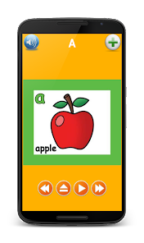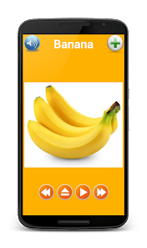Additional features include spoken alphabet, animal noises for infants, shapes for babies apps, numbers for kid's games, and amusement games and apps for preschoolers.

**ABC Kids :**

is one of the better (and free) educational Android games for kids. It’s a simple game that teaches things like the ABCs, how to read, and the difference between upper case and lower-case letters. The games are super simple and reward kids with in-game stickers for completing the various tasks. This one is obviously for younger kids around kindergarten age.Graphical user interface
**Math Kids :**

Preschoolers may learn addition, subtraction, counting, and arithmetic in a fun-free way!

You should never start your child's education too early. Toddlers, preschoolers, kindergarteners, older children, and others are eager to learn the alphabet, numbers, addition, subtraction, and other skills. Sharing clever, well-made educational applications and games with children frequently is the greatest way to support that.

The ideal way to learn the fundamentals of counting, addition, and subtraction is with Math Kids. Your toddler, kindergartener, and first grader will study early arithmetic along with sorting and reasoning abilities, laying the groundwork for a lifetime of learning.

A free educational game is intended to teach basic math concepts to young children. It has a variety of mini games that preschoolers and toddlers will enjoy playing, and the more they play, the more their arithmetic abilities will advance. Preschoolers, kindergarteners, and first graders can use Math Kids to learn how to recognize numbers and begin practicing addition and subtraction problems. They'll love completing games and collecting stickers, and you'll love seeing them develop and learn.

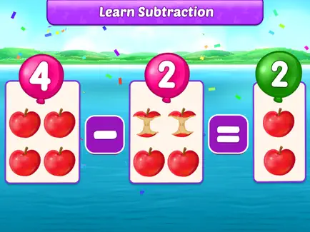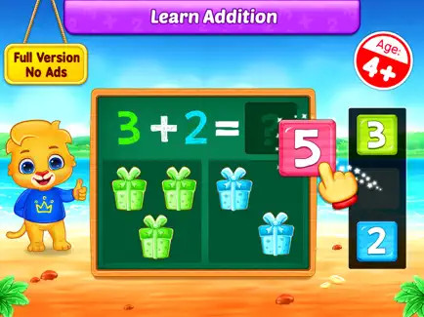

**Baby Games :**

With 15 different educational baby games, you can keep your toddlers active as they learn and develop their abilities. They will also have a lot of fun. Preschool games provide our infants a ton of interactive learning time so they may learn, build skills, and have fun all at once.

Children will learn colors, shapes, and how to follow basic, themed stories. like tending to attractive creatures or categorizing objects based on their size, color, and form.

Children will study shapes and colors while following along with straightforward theme tales. Taking care of adorable creatures, or arranging objects according to their size, color, and form.

A simple UI and gameplay with timely suggestions, designed and evaluated by child development specialists for kindergarten-aged children, will guarantee that your child never gets lost or confused in the game.

In addition, all settings and external links are secured and unavailable to children.

******Code Karts :**

Through a series of logical problems presented as a racetrack, Code Karts explains pre-coding. Additionally, while they compete, it teaches them the basics of programming! Kids may enjoy a wealth of educational information thanks to the game's more than 10 levels, diversity of perplexing obstacles, and two playing modes.

The goal of the Code Karts game is to steer the race car toward the finish line using direction bricks.

Code Karts introduces pre-coding by way of a set of logic puzzles laid out as a racetrack. Additionally, it teaches kids the fundamentals of programming while they compete! Thanks to the game's more than 10 levels, variety of confusing barriers, and two playing styles, kids may benefit from a lot of educational knowledge.

The objective of the Code Karts game is to use direction bricks to guide the race car toward the finish line.

******Shaun Learning Games for Kids**

Kids may study while having a blast with this app thanks to Shaun the Sheep and his pals. The difficulty may be changed based on the requirements of the child and is mostly geared for kids between the ages of three and eight.

There are an a plenty of entertaining games to be had here, with categories including arithmetic, navigation, memory, and creative. Children may also take a break from it all and allow their imaginations run wild as they sketch, paint, and embellish different situations. Only about a third of the games are free; the rest need a single payment to unlock.

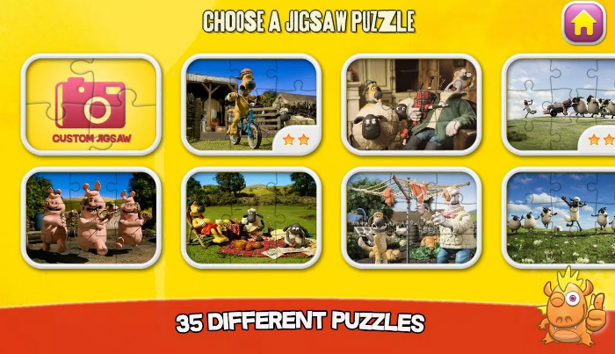Logic Land Puzzles Adventures :

The importance of logic is equal to that of more conventional topics like math and physics. Where Logic Land comes in is for this. All of the games here are made to advance the growth of memory, spatial intelligence, and logical thinking.

These games involve tasks like counting the number of bricks in a form, finding the outlier, and more. Children who successfully complete tasks gain treasure and advance Jack and Alice to other islands. A picture containing text, fabric

******Duolingo :**

With the most downloaded educational app in the world, learn a new language! A fun, cost-free program called Duolingo offers short, bite-sized instruction in 40+ languages. For vocabulary and grammar improvement, practice speaking, reading, listening, and writing.

You may practice for actual conversations in Spanish, French, Chinese, Italian, German, and other languages with the aid of Duolingo, which was created by language specialists and is beloved by millions of language learners worldwide.

You'll enjoy learning with Duolingo whether your goal is to learn a language for business, education, travel, a profession, your family and friends, or your mental health.

******Logic Gates - Electronic Simul :**

Play, simulate, and study logic gates! Learn about basic electronic devices such as the AND, OR, NOT, NAND, NOR, XOR, and XNOR logic gates.

There are several stages in this game that begin with simple gates, allowing players to pick up new skills as they play. You may practice your abilities by building your own electronic circuits with the in-game circuit builder.

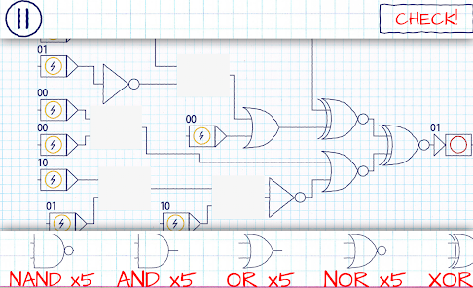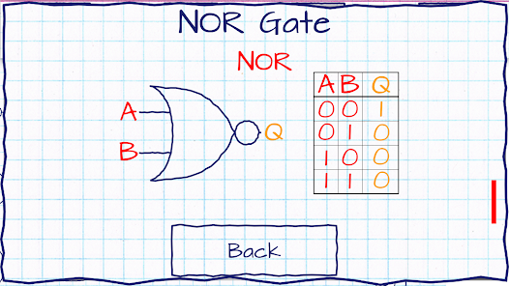

******Algorithm City :**

A engaging game with more than 50 levels, Algorithm City is geared for older kids and teaches the fundamentals of programming. The objective is to lead a small blocky penguin through each stage while collecting as many coins as you can. This is accomplished by choosing actions using a straightforward graphical interface, then observing how they unfold.

The learning curve is gradual, getting harder with each level. Even though the kid is only only given a small number of functions to work with, they must learn how to write efficient code if they want to achieve the maximum possible score. A wonderful, understated introduction to programming is Algorithm City.

******Epic - Kids' Books & Reading :**

For children aged 12 and younger, Epic is the top digital reading platform. With quick, 24/7 access to a library of thousands of books, audiobooks, instructional videos, and more, our entertaining, kid-safe, interactive reading app encourages curiosity and reading confidence in children.

